CHAPTER THREE
METHODOLOGY AND PROPOSED SYSTEM
PART A: METHODOLOGY
3.1 Introduction
This chapter describes the research methodology adopted for the development of the IoT-based Smart Energy Monitoring and Alert System. It covers the software development process model used, the justification for its selection, and a detailed description of the activities carried out in each phase.
3.2 Software Development Process Model
The Agile Software Development methodology, specifically the Scrum framework, was adopted for this project. Agile is an iterative approach to software development that emphasises flexibility, customer collaboration, and rapid delivery of functional increments (Beck et al., 2001).
Justification for Agile:
Iterative development: The system was built incrementally, starting with the simulator, then the backend, then the dashboard. Each increment was tested before moving to the next.
Changing requirements: As development progressed, new features (such as the alert engine and device map) were identified and incorporated without disrupting existing work.
Rapid feedback: The dashboard could be tested early, allowing adjustments to the visual layout and data flow.
Risk reduction: Early integration testing reduced the risk of discovering major issues late in the project.
Documentation-light: For a simulation project of this scale, Agile avoids the overhead of maintaining exhaustive documentation during development.
3.3 Phases of the Agile Process
Phase 1 Planning (Week 1-2):
The project scope, objectives, and technology stack were defined. Requirements were gathered by reviewing similar systems and identifying gaps. A project timeline was created using a Gantt chart.
Phase 2 Design (Week 3-4):
The system architecture was designed, including the three-tier structure (simulator, backend, frontend). UML diagrams (context, use case, sequence, class) were created to model the system. The database schema was designed.
Phase 3 Development Sprint 1 (Week 5-6):
The device simulator was built in Python, capable of generating realistic readings for 20 virtual meters. The Flask backend was implemented with REST API endpoints for data ingestion and retrieval. Basic WebSocket support was added.
Phase 4 Development Sprint 2 (Week 7-8):
The web dashboard was developed using HTML, CSS, and JavaScript with Chart.js for visualisation. The device grid, live charts, and alert panel were implemented. The alert engine was integrated into the backend.
Phase 5 Testing (Week 9-10):
Unit tests were written for the alert engine and data validation. Integration tests verified API endpoints and WebSocket broadcasting. Validation tests confirmed alert threshold behaviour. Security testing checked input sanitisation.
Phase 6 Documentation & Final Review (Week 11-12):
All project documentation was completed, including this report. The system was reviewed against the objectives and prepared for submission.

The following Gantt chart summarises the project timeline:
Sprint/Phase | Duration | Deliverable
Planning | Weeks 1-2 | Requirements document, Gantt chart
Design | Weeks 3-4 | Architecture diagram, UML models, DB schema
Sprint 1 | Weeks 5-6 | Simulator v1.0, Backend API v1.0
Sprint 2 | Weeks 7-8 | Dashboard v1.0, Alert engine v1.0
Testing | Weeks 9-10 | Test reports, bug fixes
Documentation | Weeks 11-12 | Final report

PART B: PROPOSED SYSTEM
3.4 Introduction to the Proposed System
The proposed system is a simulation-based IoT smart energy monitoring and alert platform. It consists of three main components: a device simulator, a backend server, and a web dashboard. The system is designed to demonstrate how IoT technologies can provide real-time energy monitoring and anomaly detection in the Nuhu Abdulai Residence.
3.5 System Architecture
The system adopts a three-tier architecture:
Tier 1 Device Simulator: A Python script that simulates 20 smart meters. Each meter generates readings every 3 seconds, including power (W), voltage (V), current (A), energy (kWh), temperature (°C), and humidity (%). Readings are sent via HTTP POST to the backend.
Tier 2 Backend Server: A Flask application that exposes REST API endpoints for receiving and querying sensor data. It uses WebSocket (Flask-SocketIO) to push real-time updates to connected dashboards. Data is persisted in a SQLite database.
Tier 3 Web Dashboard: A browser-based interface built with HTML, CSS, JavaScript, and Chart.js. It displays live device cards, real-time charts, an alert panel, and a device map. Data is received via WebSocket for real-time updates.

3.6 UML Diagrams of the Proposed System
3.6.1 Context Diagram
The context diagram shows the system boundary and external entities. The system (Smart Energy Monitor) interacts with two external entities: the Device Simulator (which sends data) and the User (who views the dashboard and acknowledges alerts).
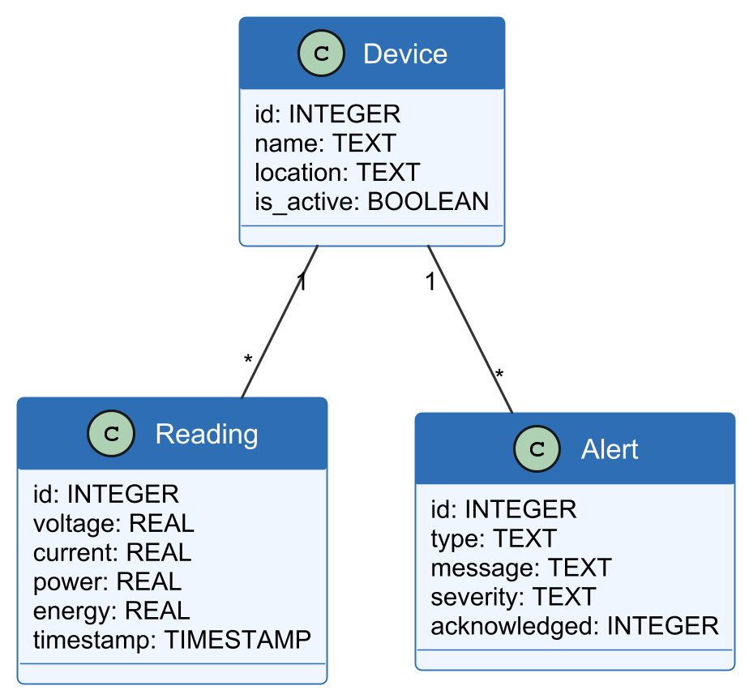
Figure 3.1: Context Diagram of the Proposed System
External Entity | Interaction | Direction
Device Simulator | Sends sensor readings via HTTP POST | → System
User | Views dashboard, acknowledges alerts | ← System →

3.6.2 Use Case Diagram
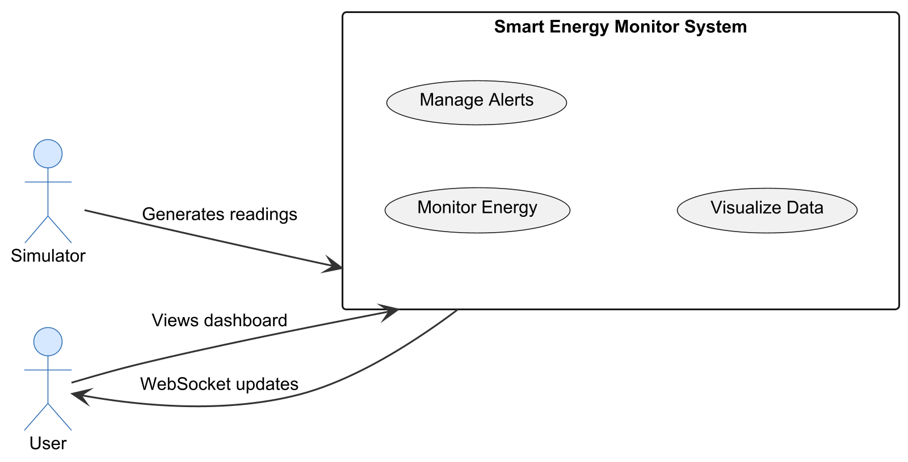
The use case diagram identifies the key actors and their interactions with the system:

Actor | Use Case | Description
User | View Device Status | See live status and readings of all devices
User | View Energy Charts | View real-time line charts of power consumption
User | View Alerts | View active and historical alerts
User | Acknowledge Alert | Mark an alert as acknowledged
User | View Device Map | See device locations on a visual map
System | Generate Reading | Simulator generates a new sensor reading
System | Detect Anomaly | Alert engine checks reading against thresholds
System | Push Update | WebSocket broadcasts new data to dashboard

3.6.3 Sequence Diagram — Data Flow
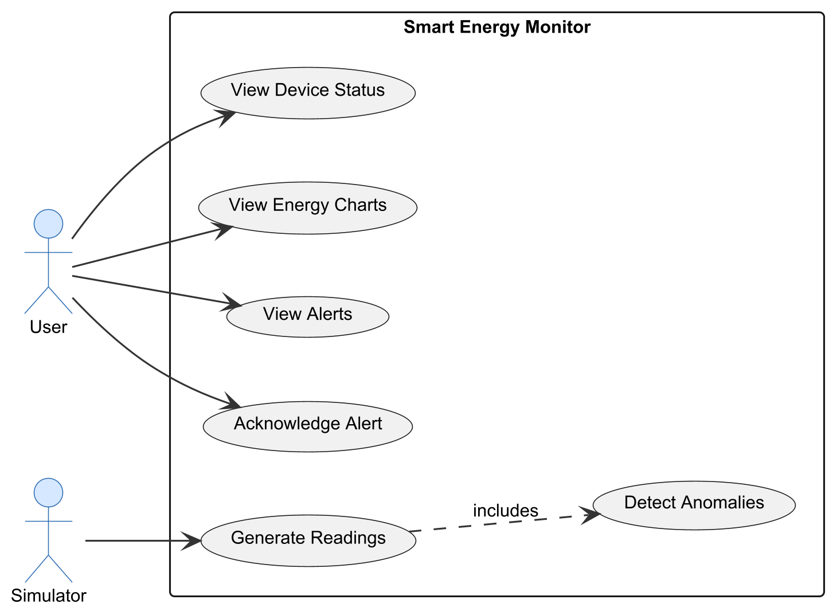
The sequence diagram illustrates the flow of data from a simulated device to the dashboard:
1. Device Simulator generates a new reading for a virtual meter.
2. Simulator sends HTTP POST to /api/reading with JSON payload (device_id, power, voltage, current, energy, temp, humidity).
3. Flask backend validates and stores the reading in SQLite.
4. Backend runs the alert engine checks if any parameter exceeds thresholds.
5. If threshold exceeded, an alert record is created in the database.
6. Backend broadcasts the new reading (and alert if any) via WebSocket to all connected dashboard clients.
7. Dashboard JavaScript receives the WebSocket message and updates the relevant chart, device card, or alert panel in real time.
8. User views updated data and may acknowledge alerts.
3.6.4 Structural and Behavioural Models (Class Diagram)
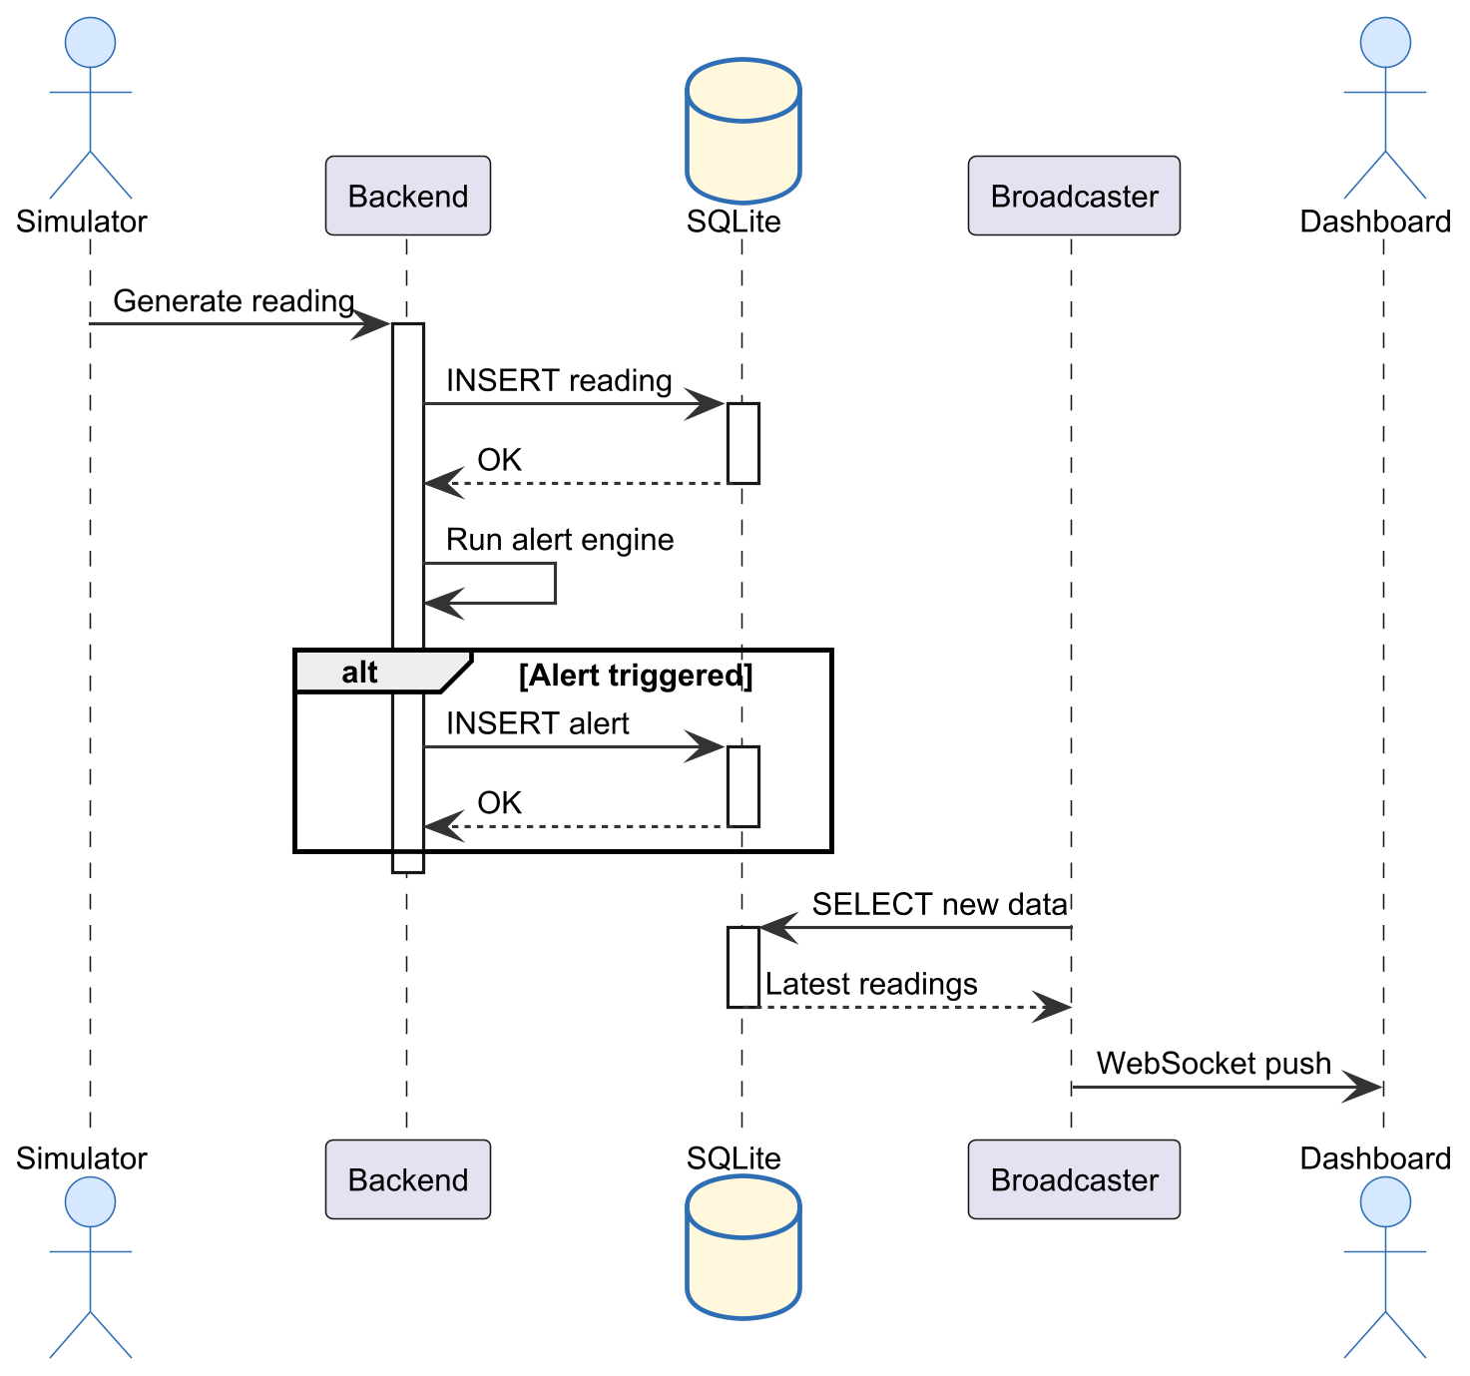
The class diagram shows the main entities, their attributes, and their relationships:
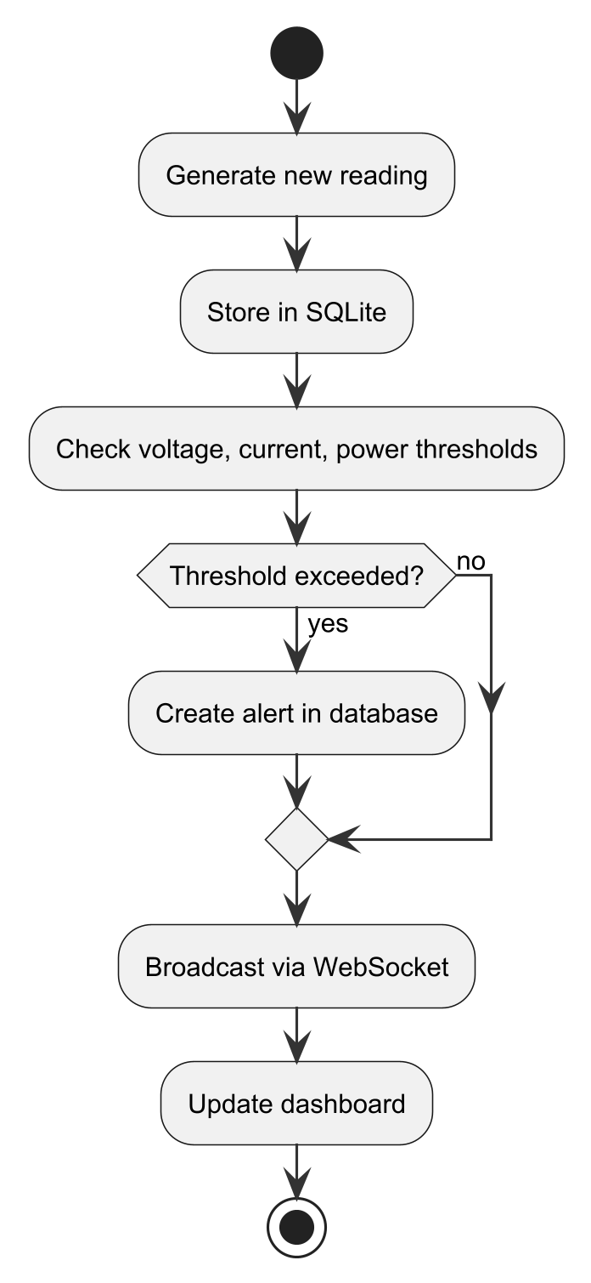
Figure 3.5: Activity Diagram - Alert Engine Flow
Class | Attributes | Methods
Device | id, name, location, device_type, is_active, created_at | to_dict()
Reading | id, device_id, power, voltage, current, energy, temp, humidity, timestamp | to_dict()
Alert | id, device_id, parameter, value, threshold, message, acknowledged, created_at | to_dict(),acknowledge()

Relationships: A Device has many Readings (one-to-many). A Device has many Alerts (one-to-many). Each Reading and Alert belongs to exactly one Device.
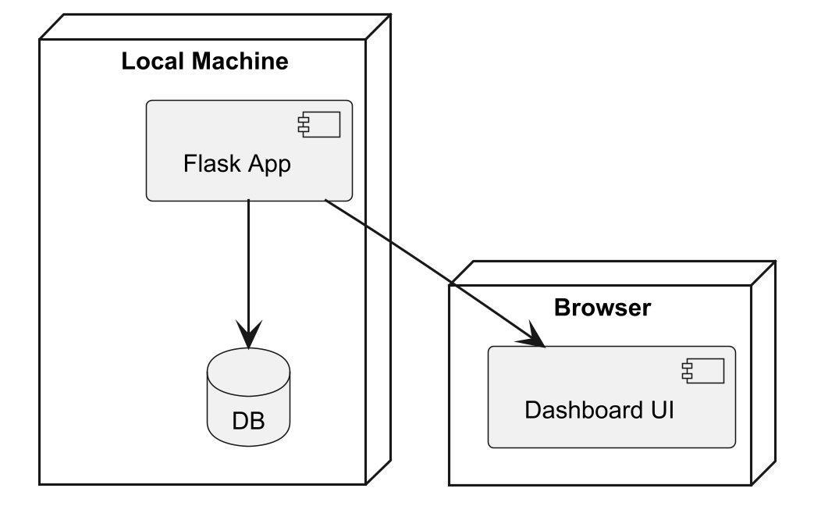
Figure 3.6: Deployment Diagram
3.7 Features of the Proposed System
20 virtual smart meters with unique IDs and location labels
Realistic data generation with configurable intervals
REST API for data ingestion and retrieval
WebSocket-based real-time dashboard updates
Live line charts for power, temperature, and humidity
Device status cards (online/offline, current readings)
Alert engine with configurable thresholds
Alert panel with acknowledge functionality
Visual device map with colour-coded status indicators
Summary statistics (total energy, active devices, peak load)
Dark mode dashboard theme
3.8 Development Tools and Environment
The proposed system was developed using the following tools and technologies: Python 3.14 as the primary programming language for the device simulator and backend server. Flask framework for building the REST API and WebSocket server. Flask-SocketIO for real-time bidirectional communication between the server and dashboard. SQLite as the database engine for storing device readings and alert records. JavaScript with Chart.js library for creating interactive real-time charts on the web dashboard. HTML5 and CSS3 for structuring and styling the user interface. Visual Studio Code as the code editor for development. Windows 11 as the development and testing platform.
3.9 REVIEW OF THE GOOD FEATURES
The proposed system offers several good features. It is entirely simulation-based, requiring no physical hardware investment or cloud subscription. The system uses modern web technologies (Python, JavaScript, Chart.js) that are accessible to students and researchers. The real-time web dashboard provides live visualisation of energy data through interactive charts and device cards. The alert engine enables proactive monitoring by notifying users when consumption exceeds predefined thresholds. The system architecture is modular, allowing individual components to be developed, tested, and maintained independently.
3.10 REVIEW OF THE BAD FEATURES
The proposed system has some limitations. As a simulation, it does not use real sensor data, so results may not fully reflect real-world conditions. The system runs on a local network and is not deployed to the cloud, limiting remote access. Hardware-related challenges such as sensor calibration and network reliability are not addressed. The alert engine uses simulated thresholds; real-world calibration would require domain expertise and historical data. The dashboard is designed for desktop browsers only and does not include a mobile application.
3.11 SUMMARY OF THE SYSTEM REVIEW
The proposed IoT-based Smart Energy Monitoring and Alert System provides a lightweight, simulation-based solution that addresses the limitations of existing platforms. It combines a Python device simulator, Flask backend with WebSocket support, and an interactive web dashboard with real-time charts and alerts. The system is designed to be accessible to students and researchers, requiring no hardware investment or cloud subscription. While it has limitations as a simulation, it successfully demonstrates the key concepts of IoT-based energy monitoring and provides a foundation for future physical deployments.
Component | Technology | Version
Backend Framework | Flask (Python) | 3.x
Real-time Communication | Flask-SocketIO | 5.x
Database | SQLite | Built-in
Frontend Charts | Chart.js | 4.x
Frontend UI | HTML5, CSS3, JavaScript | -
Simulator | Python | 3.14
Development OS | Windows 11 | -
Code Editor | VS Code | -

